**Lab Manual for Object-Oriented Programming**

#### **Lab 2**

**Basic Concepts of JAVA Programming**

|  |  |
| --- | --- |
| **Table of Contents** |  |
| 1. Introduction | 3 |
| 2. Activity Time boxing | 3 |
| 3. Objective of the experiment | 3 |
| 4. Concept Map | 3 |
| 4.1 Access Specifiers | 4 |
| 4.2 Constructors and Destructors | 4 |
| 4.3 Constructor Overloading | 4 |
| 4.4 Copy Constructor | 5 |
| 4.5 Deep Copy and Shallow Copy | 5 |
| 5. Homework before Lab | 6 |
| 6. Procedure& Tools | 7 |
| 7. Walkthrough Task | 7 |
| 8. Practice Tasks | 9 |
| 8.1 Practice Task 1 | 9 |
| 8.2 Practice Task 2 | **Error! Bookmark not defined.** |
| 8.3 Out comes | 9 |
| 8.4 Testing | 9 |
| 9. Evaluation Task (Unseen) | 10 |
| 10. Evaluation criteria | 10 |
| 11. Further Reading | 10 |
| 11.1 Books | 10 |

# Lab2: Basic Concepts of JAVA Programming

1. **Introduction**

You have looked at the basic characteristics of Java and the benefits of using Java over C++. The objective of this lab is to get familiar with the basic concepts of java like implementation of Access Specifiers, Constructors and Destructors, Constructor Overloading.

1. Revise Lecture No. 5 and 6
2. Relevant Lecture Material
3. Text Book: Java: How to Program by Paul J. Deitel, Harvey M. Deitel
   1. Read pages: 11-15, 55-63
   2. Revise the object-oriented concepts.

1. **Activity Time boxing**

Table 1: Activity Time Boxing

|  |  |  |  |
| --- | --- | --- | --- |
| **Task No.** | **Activity Name** | **Activity time** | **Total Time** |
| 5.1 | Evaluation of Design | 20mins | 20mins |
| 6.2 | Setting-up Path for JDK | 30mins | 30mins |
| 6.2 | Walkthrough Tasks | 30mins | 30mins |
| 7 | Practice tasks | 15mins for each task | 60mins |
| 8 | Evaluation Task | 60mins for all assigned task | 30mins |

1. **Objective of the experiment**

* To get basic understanding of Java programming
* To write simple class and how to run and compile it
* To get an understanding of basic java concepts.
* To understand the command line arguments and their purpose.

1. **Concept Map**

This section provides you the overview of the concepts that will be discussed and implemented in this lab.

* 1. **Access Specifiers**

There are four types of Java access modifiers:

* + 1. **Private**: The access level of a private modifier is only within the class. It cannot be accessed from outside the class.
    2. **Default**: The access level of a default modifier is only within the package. It cannot be accessed from outside the package. If you do not specify any access level, it will be the default.
    3. **Protected**: The access level of a protected modifier is within the package and outside the package through child class. If you do not make the child class, it cannot be accessed from outside the package.
    4. **Public**: The access level of a public modifier is everywhere. It can be accessed from within the class, outside the class, within the package and outside the package.

**Encapsulation**

Encapsulation is one of the fundamental principles of object-oriented programming (OOP) and it refers to the bundling of data (attributes or properties) and methods (functions or procedures) that operate on the data into a single unit, called a class. Encapsulation hides the internal state of an object from the outside world and only exposes the necessary functionalities through well-defined interfaces.

**Getters and Setters**

Getters and setters are methods used to access and modify the private attributes of an object in object-oriented programming. Getters retrieve the value of an attribute, providing read-only access, while setters modify the value of an attribute, providing write-only or read-write access. By encapsulating attribute access within methods, getters and setters enforce data encapsulation and enable controlled interaction with object attributes.

public int getAge(){  
 return age;  
}  
public void setAge(int a){  
 age = a;  
}  
public String getName(){  
 return name;  
}

public class Human {  
 private int age=20;  
 private String name="Waqas";  
 public Human(){ *//Default constructor* age = 12;  
 name = "Waqas";  
 }  
 public Human(int a, String n){ *//parametrized constructor* age = a;  
 name = n;  
 }  
 public int getAge(){  
 return age;  
 }  
 public void setAge(int a){  
 age = a;  
 }  
 public String getName(){  
 return name;  
 }  
  
 public void setName(String n) {  
 name = n;  
 }  
}

public class Main {  
  
 public static void main(String[] args) {  
 Human h1 = new Human();  
 Human h2 = new Human();  
 Human h3 = new Human(27, "Farooq");  
 h1.setName("Ubaid:");  
 h1.setAge(27);  
 System.*out*.print(h1.getName());  
 System.*out*.println(h1.getAge());  
 System.*out*.println(h2.getName()+ ": \t" + h2.getAge());  
 System.*out*.print(h3.getName()+ ": \t" + h3.getAge());  
  
  
*// h1.name = "Waqas";  
// h1.age = 20;  
// System.out.println(h1.getName());  
// System.out.println(h1.getAge());* }  
}

1. **Homework before Lab**

Read and understand the concepts given in concept map.

1. **Procedure& Tools**

Java Development Kit (JDK) 19 NetBeans 17

1. **Walkthrough Task**

Open the netbeans OR IntelliJidea and create a project. Write the following program that consist of a class Person and main class named Lab1 and implement all the above-mentioned concepts discussed in concept map.

**Person.java**

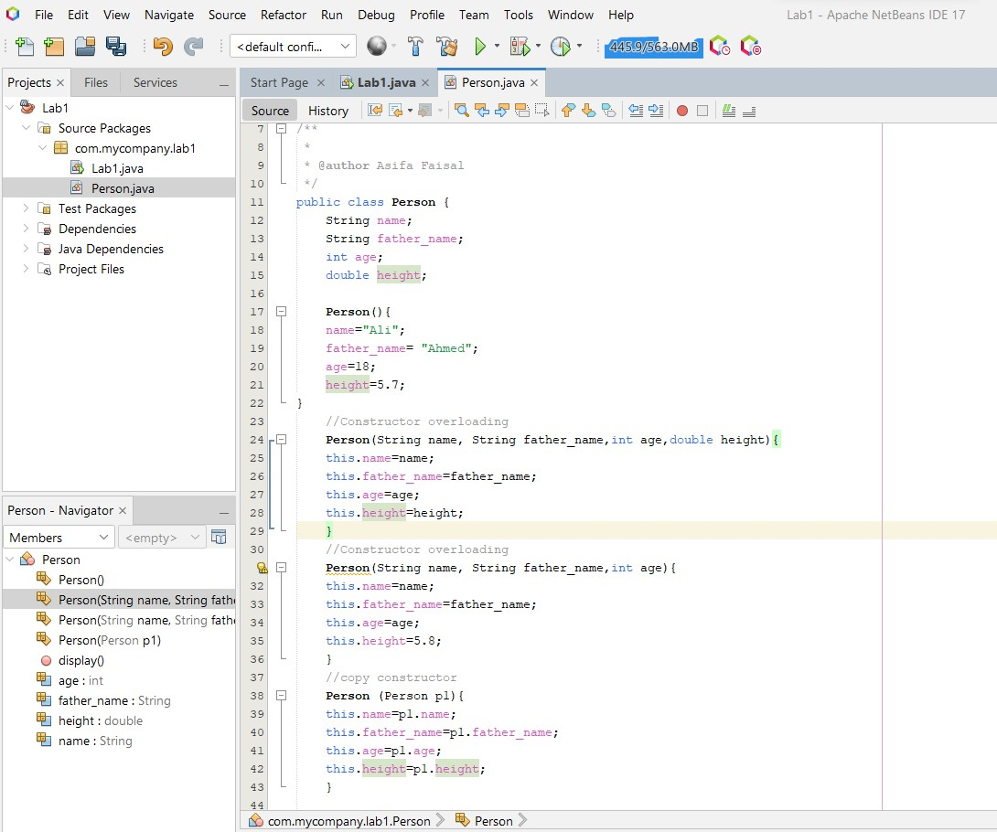

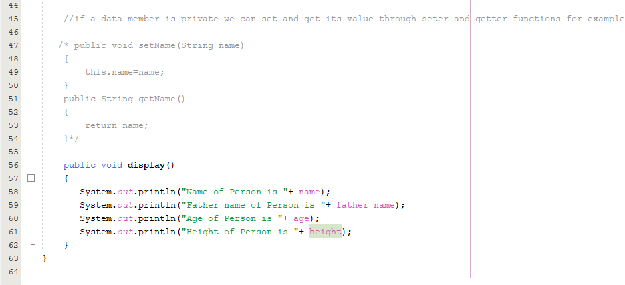

**Lab1.java (main class)**

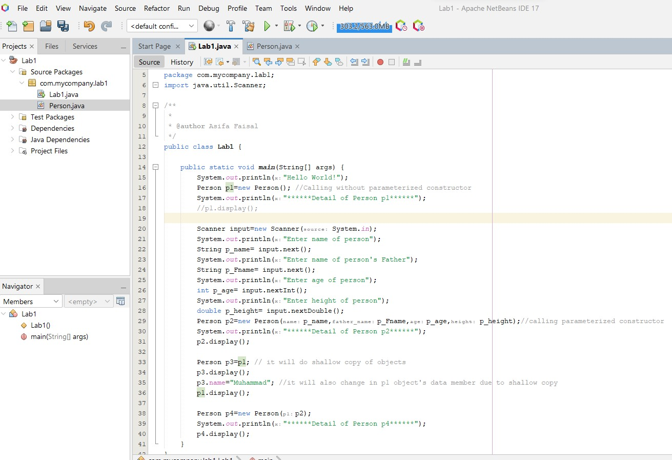

1. **Practice Tasks**

This section will provide more practice exercises which you need to finish during the lab. You need to finish the tasks in the required time. When you finish them, submit your task to your instructor.

* 1. **Practice Task 1 [Expected time = 15mins]**

Create a class Student. The data members of the class are regNo (string), name (String), age (int), CGPA (double). Then Implement member functions to;

* + 1. Make CGPA private member.
    2. Create a parameterized constructor that will set only name and regNo through parameters and other two will be taking from user in constructor too.
    3. Make setter getter for private data members.
    4. Display the values of all data members.

Create another class TestStudent.java to test Student class. Take input via scanner class.

* 1. **Practice Task 2**

Write a class called Programs. Initialize a variable name **Input Number,** initialize it using **constructors** by taking Input from user (Come from Main Class). In this class Create the following function:

* + 1. Create getter and setter for variable.
    2. Make the Function which can check and display the number is even or odd.
    3. Make the function which can compute the factorial of this number
    4. Make the function which can check and display the number is prime or not.

In Main Class, Create the object of programs class. Take the input from user using joptionpane class. The user input pass via constructor. After that make a Menu like given below

**\*\*\*\*\*\*\*\*\*\*\*\*\*\*\*\*\*\*\*\*\*\*\*\*MENU\*\*\*\*\*\*\*\*\*\*\*\*\*\*\*\*\*\*\*\*\*\*\*\*\*\*\*\*\*\*\*\*\*\*\*\*\***

**\*\*\*\*\*\*\*\*\*\*Press 1 for to check whether the Number is even or odd\*\*\*\*\*\*\*\*\*\*\***

**\*\*\*\*\*\*\*\*\*\*\*\*\*\*Press 2 for to find the factorial of a Number \*\*\*\*\*\*\*\*\*\*\*\*\*\*\*\***

**\*\*\*\*\*\*\*\*\*\*Press 3 for to check whether the Number is Prime or Not\*\*\*\*\*\*\*\*\*\*\*** Take the choice from user using Scanner class and passes to Switch and calls the functions in respective cases. The Switch Concept of Java and C++ is same.

* 1. **Out comes**

After completing this lab, student will be able to setup JDK. He/ She will also be able to compile and run basic Java programs.

**8.4 Testing**

This section provides you the test cases to test the working of your program. If you get the desired mentioned outputs for the given set of inputs then your program is right.

**Test Cases for Practice Task-1**

|  |  |
| --- | --- |
| Sample Inputs | Sample Outputs |
| Set the following values Name = Ali  RegNo = BC113100  Age = 23  CGPA = 3.00 | Name = Ali  RegNo = BC113100  Age = 23  CGPA = 3.00 |

**Test Cases for Practice Task-2**

|  |  |
| --- | --- |
| Sample Inputs | Sample Outputs |
| Length: 4  width: 10 | Length = 5  Width = 11  Area = 55 |

1. **Evaluation Task (Unseen) [Expected time = 30mins for tasks]**

The lab instructor will give you unseen task depending upon the progress of the class.

1. **Evaluation criteria**

The evaluation criteria for this lab will be based on the completion of the following tasks. Each task is assigned the marks percentage which will be evaluated by the instructor in the lab whether the student has finished the complete/partial task(s).

Table 3: Evaluation of the Lab

|  |  |  |  |
| --- | --- | --- | --- |
| **Sr. No.** | **Task No** | **Description** | **Marks** |
| 1 | 4 | Problem Modeling | 20 |
| 2 | 6 | Procedures and Tools | 10 |
| 3 | 7 | Practice tasks and Testing | 35 |
| 4 | 8 | Evaluation Tasks (Unseen) | 20 |
| 5 |  | Comments | 5 |
| 6 |  | Good Programming Practices | 10 |

1. **Further Reading**

This section provides the references to further polish your skills.

* 1. **Books**

**Text Book:**

* *Java: How to Program by Paul J. Deitel, Harvey M. Deitel. Eighth Edition*
* *Java Beginners Guide:* [*http://www.oracle.com/events/global/en/java-*](http://www.oracle.com/events/global/en/java-) *outreach/resources/java-a-beginners-guide-1720064.pdf*